HACETTEPE UNIVERSITY

DEPARTMENT OF COMPUTER ENGINEERING BBM233



Name : Mehmet Taha, Mehmet Emin, Alperen

Surname : Usta, Akoğuz, Ekinci

Number : 21527472,21626895,21627188

Subject : Design 4 bit prime number counter with JK flip flop(s)

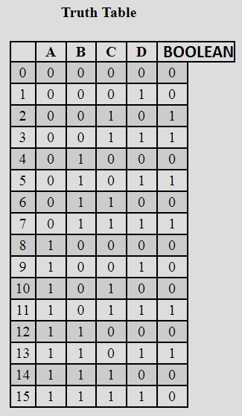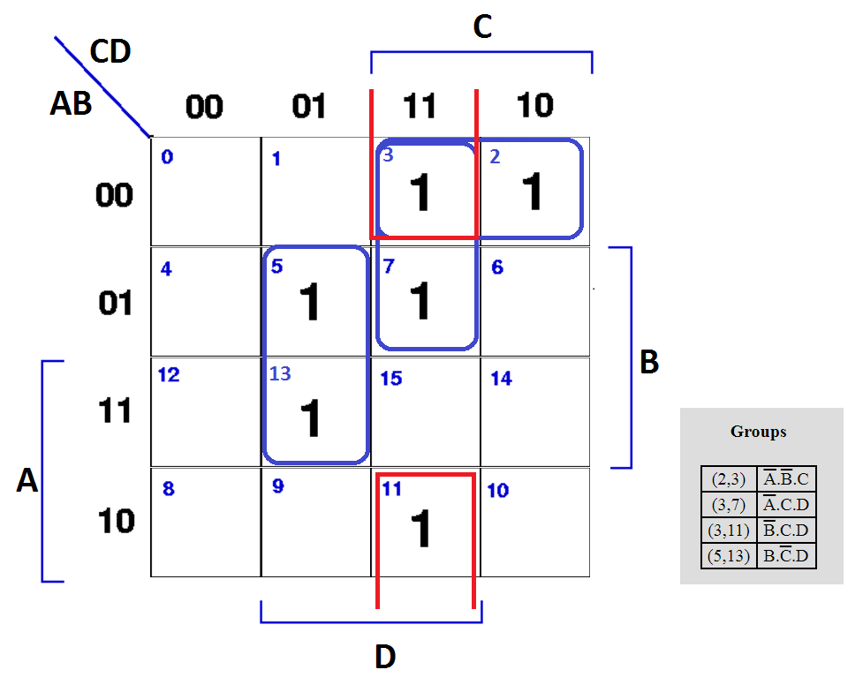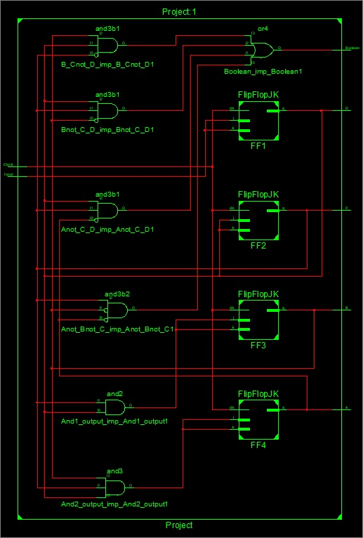

**We defined a standart JK-FlipFlop. Then used it to make a 4-bit Up Counter.From the K-map of the prime numbers we found the functions fort he numbers and implemented them as AND/OR Gates.**

**We printed Each cycle, thus got prime numbers with the “Boolean” value equal to 1.**

